

SERVICES
FOR
NON-PROFITS

“SERVICES FOR NON-PROFITS”

HOSTED ORGANIZATION FUNDS

Cemetery Funds
Dundas Cemetery Fund
Highfield Cemetery
Old Protestant Burying Ground
Tryon’s People Cemetery

Masonic Funds
T. Arthur Dawson Masonic
Fund
C. Gordon Lord Scholarship
Fund
MacMillan-Bagnall Shrine
Trust

Other
Architects Assn. of PEI
Hospice Association
ALS Society of PEI
PEI 4H Trust Fund
Anonymous #2

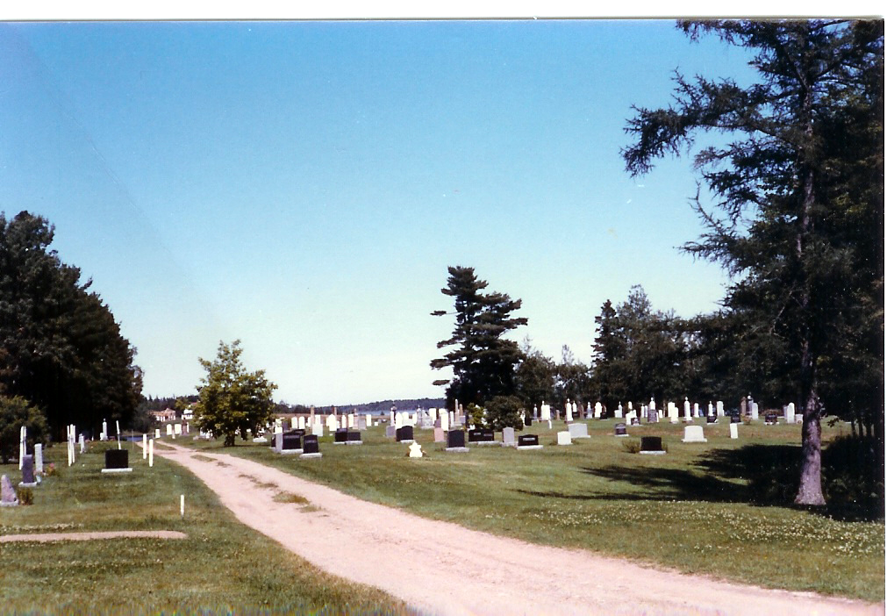

The Community Foundation of Prince Edward Island is pleased to offer a variety of services to the non-profit sector on Prince Edward Island. A list of our hosted funds is shown to the right.

Services
- Professional Administration of Funds – is available through Foundation staff, a standing investment committee and a professional investment management team

- Broad range of grant making expertise to handle call for and receipt of applications and proposals, , development of criteria and selection criteria, convening of selection committees, and administrative follow-up

- Low-cost fund management services resulting in significant savings from including your funds as part of a much larger investment portfolio.

- Donor Relations includes the design of customized giving plans and granting interests, gifts of appreciated securities and real prooperty, estate bequests, etc.

- Administration of funds in perpetuity ensuring both growth and care in future years.

To take advantage of this service:

- Review Foundation documents
- Meet with us to review your circumstances and special needs
- Review documentation
- Seek authorization from your Board
- Complete customized agreement..

Investment history since 2003.
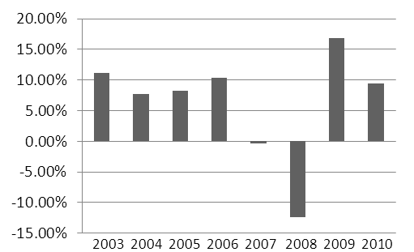

If you have any interest in this service, contact a Director or call us at 902 892-3440. CFPEI is interested in discussing how your fund would fit in.

The Community Foundation
of Prince Edward Island
Ten reasons people choose community foundations.
one
We are a local organization with deep roots in the community, and part of a nationwide movement whose support we build and share.
two
We bring donors to the table as community builders, working closely with them to align their philanthropic vision with the community’s needs.
three
We identify long-term needs and opportunities and invest in solutions that let our communities guide their own future.
four
We take a broad and inclusive view of what a community is, and provide grants to the widest possible range of organizations and initiatives.
five
We provide highly personal and flexible service, accepting a wide variety of assets and offering donors maximum tax advantage.
six
We build permanent funds and those that can respond to immediate needs, helping our communities ensure vital futures.
seven
We multiply the impact of gift dollars by pooling them with other gifts.
eight
We believe that diversity is strength, so we bring the entire community together to stimulate new ideas, build participation and strengthen community philanthropy.
nine
We are transparent and reputable stewards of community resources, committed to being accountable, accessible and responsive.
ten
We build community vitality – the unique and essential spirit that flourishes when people believe their community holds possibilities for everyone.

THE FOUNDATION

The Community Foundation of PEI is a volunteer driven, registered, non-profit, charitable organization. Our mission is to improve quality of life on PEI through the creation and building of endowment funds that will help ensure vital futures for Island communities.

The Community Foundation of PEI provides a means for individuals, families, community groups, corporations, and private foundations to support philanthropic activities which invest in sustainable solutions to community needs. We connect people who care with causes that matter.

The Community Foundation of PEI honours the vision and wisdom of donors and guides disbursements according to their wishes. We facilitate and simplify donor-directed giving and help establish endowments in perpetuity. We manage trust funds with diligence and transparency and adhere to conventional reporting practices.
THE BOARD

Direction is provided by a 12 person, volunteer, community minded Board of Directors representing a broad cross-section of life on Prince Edward Island. Much of the success of the Foundation can be attributed to the hard work and generosity of the individual directors.
CURRENT DIRECTORS

John Robinson Tom Davies Joyce Gaudet
Tracey Laughlin James Travers Rod Nicholson
Donald Glendenning Andrew Daggett Stanley MacDonald
Rogers Bell Steve McQuaid Carol Fraser

RECENT ACHIEVEMENTS

- Annual granting of more than $60,000 to charitable organizations and causes
- Investment portfolio over $1,500,000
- Developed a network of Summer Islanders interested in giving back to their adopted home;
- Capacity building and leadership workshops for the charitable sector
- Led an $800,000 project to help arts and heritage organizations gain long term stability
- Receipts acceptable to IRS for US citizens

I am impressed with the ability of the Foundation
to design funds that reflect both donor interests and
community needs – Dr. Thomas Hall

The Community Foundation of Prince Edward Island
Suite 105, Queen Square Center, 119 Queen Street
Charlottetown, PE CIA 4B3
Telephone: (902) 892-3440; Fax: (902) 892-0880
Email: cfpei@pei.aibn.com Web site: www.cfpei.ca

Registration: Canada: 890011190 RR0001 USA: 30-0050801
05 2011-04-01 Cemetery Funds

